COSC 3P93
Week 4 – Performance

What is Performance?
- In computing, performance is defined by 2 factors:
  - Computational requirements -> what needs to be done
  - Computing resources -> what it costs to do it
- Computational problems translate to requirements
- Computing resources interplay and tradeoff
- Performance ~= 1 / Resources for Solution
- Costs h/w, time, energy, and money

Why Do We Care About Performance
- Performance itself is a measure of how well the computational requirements can be satisfied
- We evaluate performance to understand the relationships between requirements and resources
  - Decide how to change ‘solutions’ to target objectives
- Performance measures reflect decisions about how well “solutions” are able to satisfy the computational requirements

What is Parallel Performance?
- Here we are concerned with performance issues when using a parallel computing environment
  - Performance w/ respect to parallel computation
- Performance is the raison d’etre for parallelism
  - Parallel performance vs sequential performance
  - If the performance is not better then parallelism is not necessary
- Parallel processing includes techniques and technologies necessary to compute in parallel
  - Hardware, networks, OSs, parallel libraries, languages, compilers, algorithms, tools,…
- Parallelism must deliver performance

Performance Expectation (Loss)
- If each processor is rated at ‘k’ MFLOPS and there are ‘p’ processors, should we see k*p MFLOPS of performance?
- If it takes 100 seconds on 10 processors, shouldn’t it take 10 seconds on 10 processors?
- Several causes affect performance
  - Each must be understood separately
  - But they interact w/ each other in complex ways
    - Solution to one problem may create another
    - One problem may mask another
- Scaling (system, problem size) can change conditions
- Need to understand performance space

Embarrassingly Parallel Computations
- An embarrassingly parallel computation is one that can be divided into completely independent parts that can be executed simultaneously
  - In a truly embarrassingly parallel computation there is no interaction between separate processes
  - In a nearly embarrassingly parallel computation results must be distributed and collected/combined in some way
- Embarrassingly parallel computations have potential to achieve maximum speedup on parallel platforms
  - If it takes ‘T’ time sequentially, there is the potential to achieve T/p times running in parallel w/ ‘p’ processors
  - What would cause this not to be the case always?

Scalability
- A program can scale up to use many processors
  - What does this mean?
- How do you evaluate scalability?
- How do you evaluate scalability goodness?
- Comparative evaluation:
  - If double the # of processors, what to expect?
  - Is scalability linear?
- Use parallel efficiency measure
  - Is efficiency retained as problem size increases?
- Apply performance metrics
- In general, a problem is scalable if it can handle ever increasing problem sizes
- The problem is strongly scalable if we increase the number of processes/threads and keep the efficiency fixed without increasing problem size
- The problem is weakly scalable if we keep the efficiency fixed by increasing the problem size at the same rate as we increase the number of processes/threads

Performance and Scalability
- Evaluation:
  - Sequential runtime (T_{seq}) is a function of problem size and architecture
  - Parallel runtime (T_{par}) is a function of:
    - Problem size and parallel architecture
    - # processors used in the execution
  - Parallel performance affected by the algorithm and the architecture
- Scalability = Ability of the algorithm to achieve performance gains proportional to the number of processors and the size of the problem

Taking Timings
- What is time?
- Start to finish?
- A program segment of interest?
- CPU time?
- Wall clock time?

Performance Metrics and Formulas
- ‘T₁’ is the execution time on a single processor
- ‘T_{p}’ is the execution time on a N-processor system
- S(p) (AKA S_{p}) is the speedup:
  - S(p) = T₁ / T_{p}
- E(p) (AKA E_{p}) is the efficiency:
  - Efficiency = S_{p} / N = (T_{seq}/T_{par})/N = T_{seq} / (N * T_{par})
- Cost(p) (AKA C_{p}) is the cost:
  - Cost = N * T_{p}
- Parallel algorithm cost is optimal
  - Parallel-time = sequential time
    - C_{p} = T₁
    - E_{p} = 100%

Speedups and Efficiency
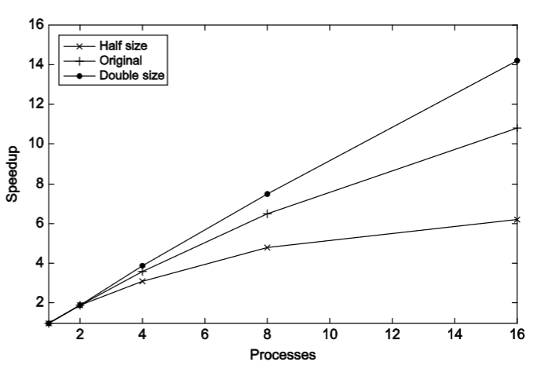
- Parallel program
p | 1 | 2 | 4 | 8 | 16
S | 1.0 | 1.9 | 3.6 | 6.5 | 10.8
E = S/p | 1.0 | 0.95 | 0.90 | 0.81 | 0.68

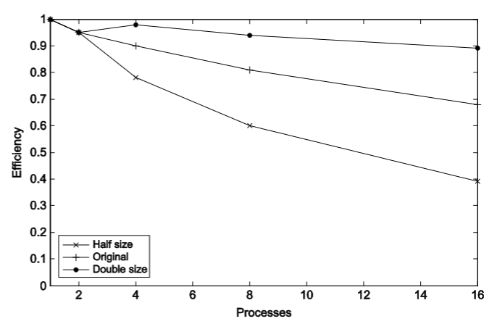
- Parallel program on different problem sizes
 | p | 1 | 2 | 4 | 8 | 16
Half | S  E | 1.0  1.0 | 1.9  0.95 | 3.1  0.78 | 4.8  0.60 | 6.2  0.39
Original | S  E | 1.0  1.0 | 1.9  0.95 | 3.6  0.90 | 6.5  0.81 | 10.8  0.68
Double | S  E | 1.0  1.0 | 1.9  0.95 | 3.9  0.98 | 7.5  0.94 | 14.2  0.89

Limits and Costs of Parallel Programming
- Amdahl’s Law: states that potential program speedup is defined by the fraction of code (P) that can be parallelized:
  - $speedup=\frac{1}{1-p}$
  - If none of the code can be parallelized: p = 0 and the speedup = 1 (no speedup)
  - If all of the code can be parallelized: p = 1 and the speedup is infinite (in theory)
  - If 50% of the code can be parallelized: maximum speedup = 2 (the code will run twice as fast)
  - Introducing the number of processors performing the parallel fraction of work.
    - The relationship can be modeled by where P = parallel fraction, N = number of processors and S = serial fraction.

Amdahl’s Law (Fixed Size Speedup)
- Let S be the fraction of a program that is sequential
  - Then 1 – S is the fraction of the program that can be parallelized
- Let T1 be the execution time on 1 processor
- Let Tp be the execution time on N processors
- Sp is the speedup
  - $S_{p}=\frac{T_{1}}{T_{p}}$
  - $=\frac{T_{1}}{\left(S*T_{1}+\left(1-S\right)*\frac{T_{1}}{N}\right)}$
  - $=\frac{1}{(S+\frac{\left(1-S\right)}{N})}$
- As N -> ∞, S_{p} = 1/S
- Simplifying: $S_{p}=\frac{1}{\frac{p}{n}+S}$
  - Where:
    - p = parallel fraction
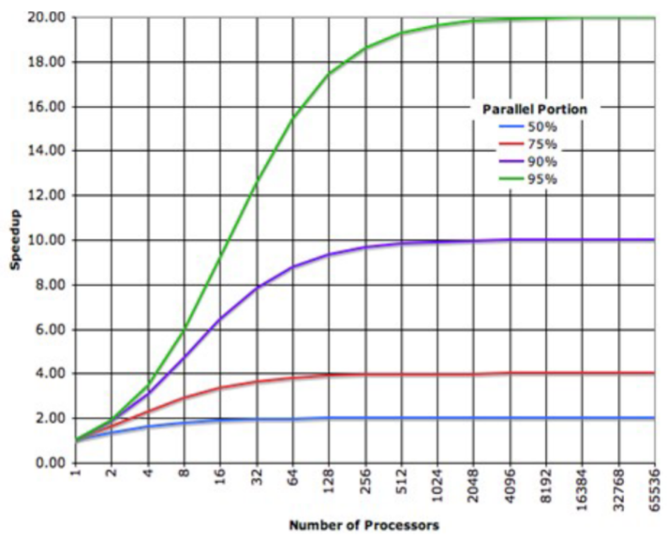
    - N = number of processors
    - S = serial fraction
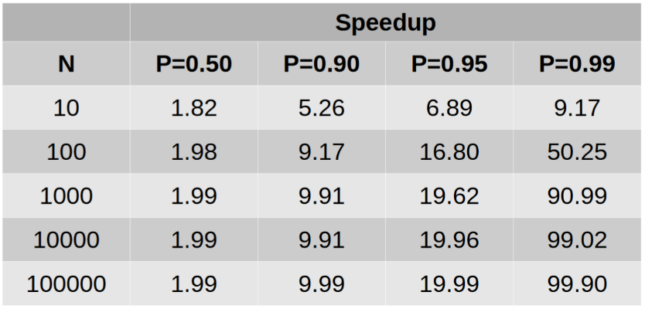

- It soon becomes apparent that there are limits to the scalability of parallelism:
  - There will reach a point when performance gains are negligible no matter how many compute resources we pump at the problem (law of diminishing returns)
  - See table above

Amdahl’s Law and Scalability
- Scalability (reminder) = ability of the algorithm to achieve performance gains proportional to the number of processors and the size of the problem
- When does Amdahl’s law apply?
  - When the problem size is fixed
  - Strong scaling (N -> ∞, S_{p} -> S∞ = 1 / S)
  - Speedup bound is determined by the degree of sequential execution time in the computation, not the number of processors!
    - This is not good. Why?
    - Perfect efficiency is hard to achieve
- Effect of overhead: assume a perfect, virtual “parallelization” of the serial code
  - $T_{par}=\frac{T_{seq}}{p}+T_{overhead}=>T_{p}=\frac{T_{1}}{N}+T_{overhead}$

Gustafson-Baris’ Law (Scaled Speedup)
- Often interested in larger problems when scaling
  - How big of a problem can be run (HPC Linpack)
  - Constrain problem size by parallel time
- Assume parallel time is kept constant
  - T_{p} is constant
  - P_{seq} is the fraction of T_{p} spent in sequential execution
  - P_{par} is the fraction of T_{p} spent in parallel execution
- What is the execution time on one processor?
  - $T_{s}=P_{seq}*T_{p}+\left(1-P_{seq}\right)*N*T_{p}$
- What is the speedup in this case?
  - $S_{p}=\frac{T_{s}}{T_{p}}$
  - $=\frac{P_{seq}*T_{p}+\left(1-P_{seq}\right)*N*T_{p}}{T_{p}}$
  - $=P_{seq}+\left(1-P_{seq}\right)*N$
  - $=\left(1-P_{par}\right)+P_{par}*N$

Gustafson-Baris’ Law and Scalability
- When does Gustafson-Baris’ law apply?
  - When the problem size can increase as the number of processors increase
  - Weak scaling -> S_{p} = P_{seq} + N * P_{par}
  - Speedup function includes the # of processors
  - Can maintain or increase parallel efficiency as the problem scales

Amdahl vs Gustafson-Baris
- Both -> serial part of same size
- Amdahl: parallel splitting indefinitely
- Gustafson-Baris: parallel growing indefinitely (making the sequential fraction smaller)
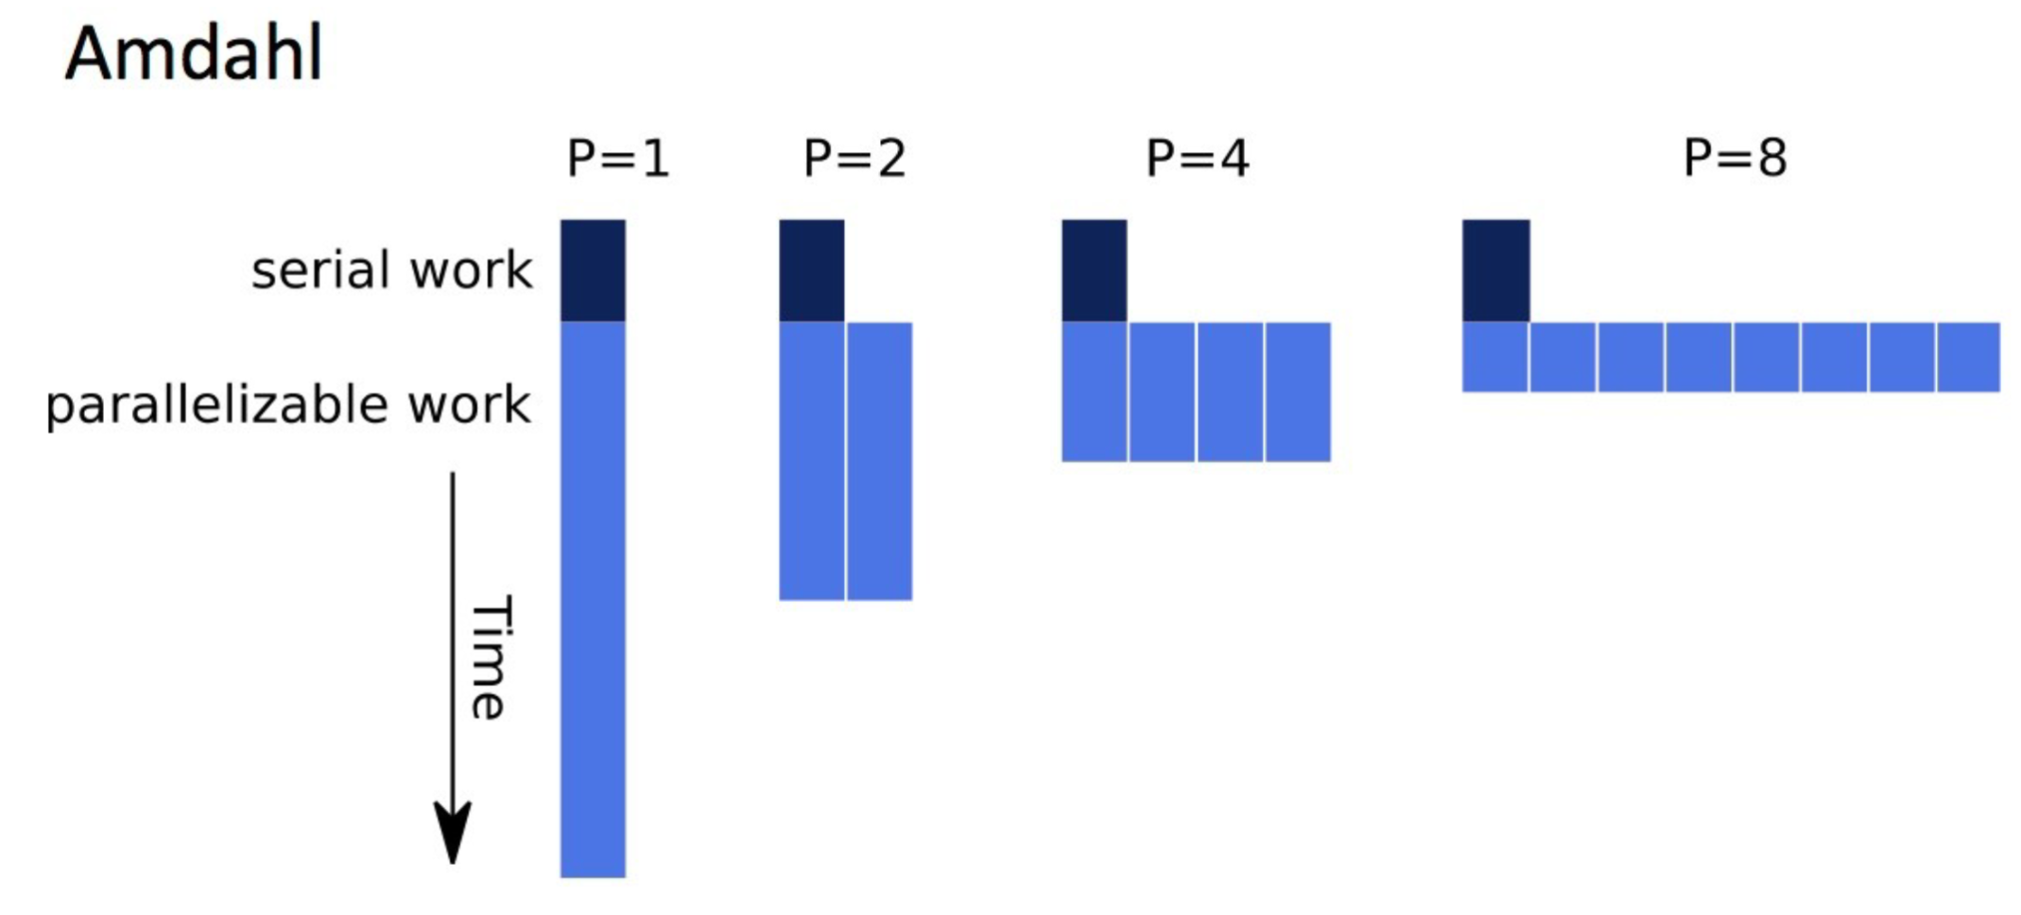
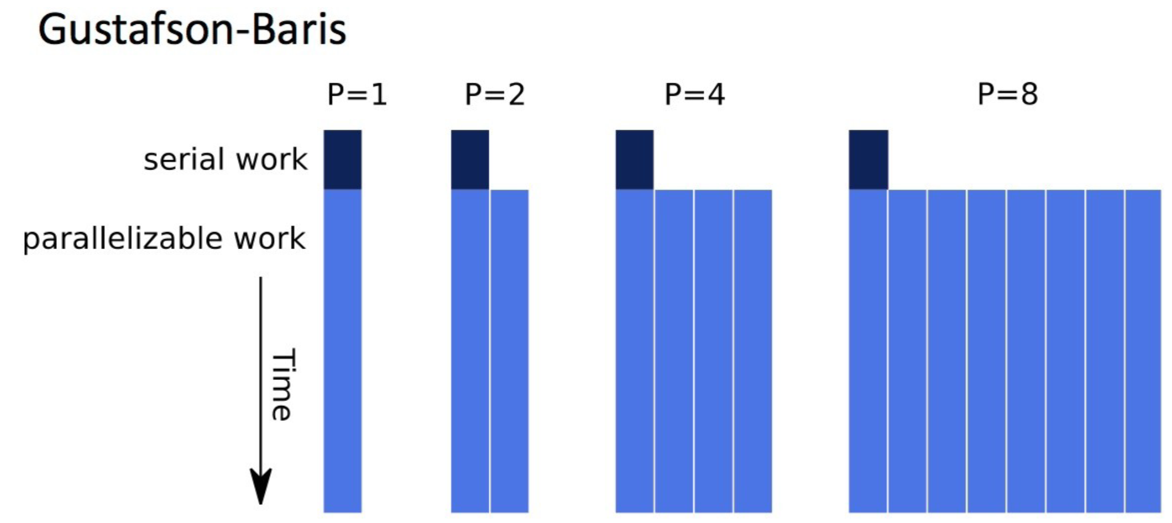
DAG Model of Computation
- Think of a program as a directed acyclic graph (DAG) of tasks
  - A task cannot execute until all the inputs to the tasks are available
  - These inputs come from outputs of earlier executing tasks
  - DAG shows explicitly the task dependencies (similar to a resource graph)
- Think of the h/w as consisting of workers (processors)
- Consider a greedy scheduler of the DAG tasks to workers
  - No worker is idle while there are tasks still to execute
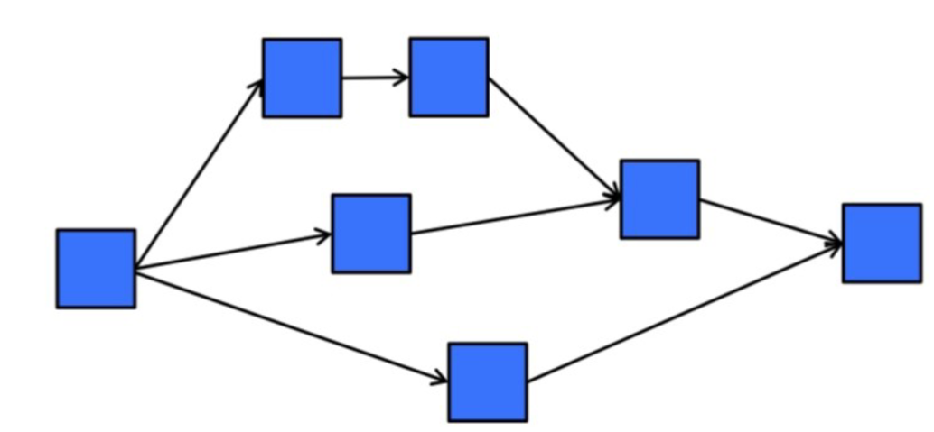
Work-Span Model
- T_{p} = time to run with ‘p’ worker
- T₁ = time for serial execution (execution of all tasks w/ one worker)
- Sum of all work
- T∞ = span (time along the critical path)
- Critical path = sequence of task execution (path) through the DAG that takes the longest time to execute
  - Assumes an infinite # of workers available
- Eg.
  - Let each task take 1 unit of time
  - DAG at the right has 7 tasks
  - T₁ = 7
    - All tasks have to be executed
    - Tasks are executed in serial order
    - Can the execution be in any order?
  - T∞ = 5
    - Time along the critical path
    - In this case, it is the longest path length of any task order that maintains necessary dependencies
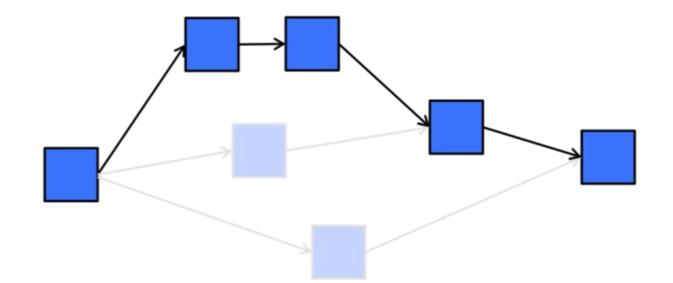

Lower/Upper Bound on Greedy Scheduling
- Suppose we only have ‘p’ workers
- We can write a work span formula to derive a lower bound on T_{p}
  - Max(T₁ / P, T∞) <= T_{p}
- T∞ is the best possible execution time
- Brent’s Lemma derives an upper bound
  - Capture the additional cost executing the other tasks not on the critical path
  - Assume we can do so w/out overhead
  - T_{P} <= ((T₁ - T∞) / P) + T∞
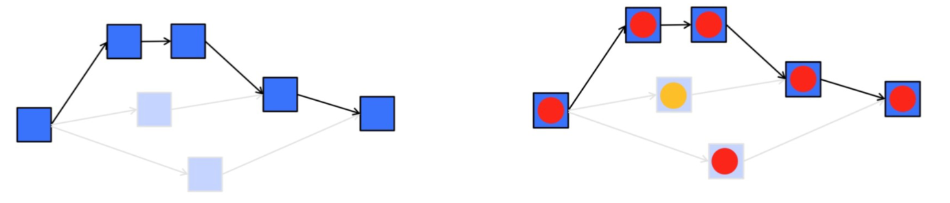

- Consider Brent’s Lemma for 2 Processors
  - T₁ = 7
  - T∞ = 5
  - T₂ <= (T₁ - T∞) / P + T∞
  - <= ((7-5) / 2) + 5
  - <= 6
- Note: Amdahl was an optimist:
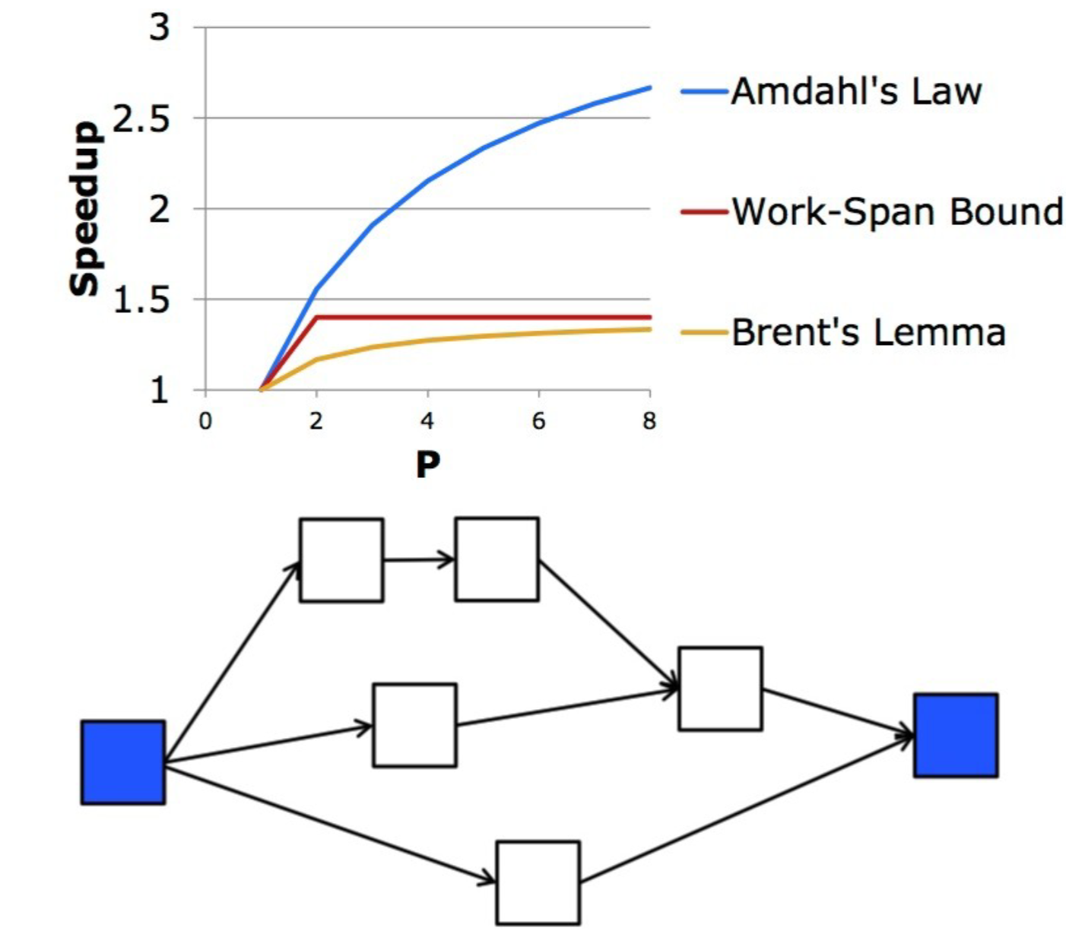

Estimating Running Time
- Scalability Requires that T∞ be dominated by T₁
  - T_{p} ~= T₁ / P + T∞ if T∞ << T₁
- Increasing work hurts parallel execution proportionately
- The span impacts scalability
  - Even for finite P

Parallel Slack
- Sufficient Parallelism implies linear speedup
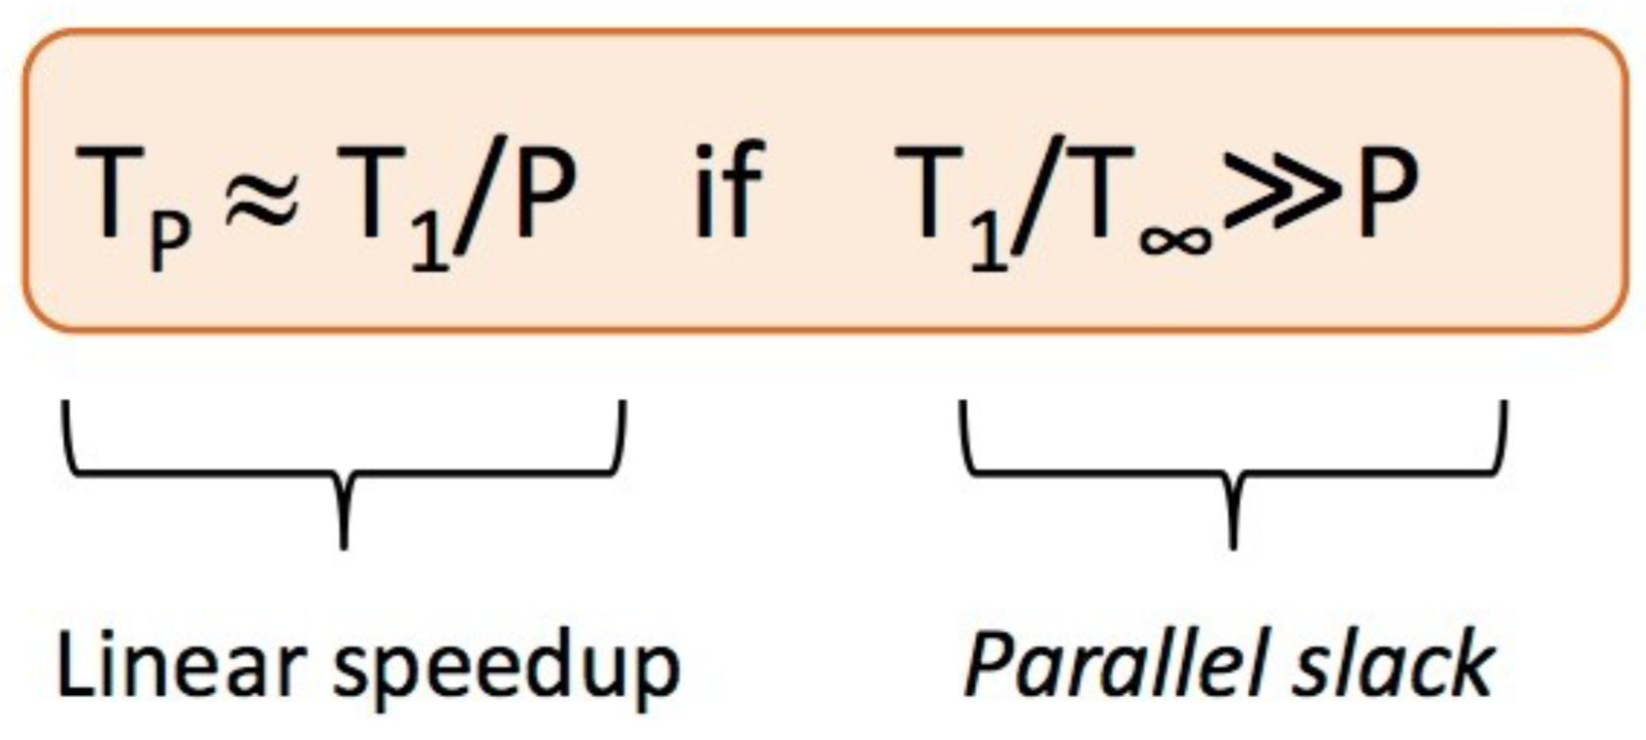

Asymptotic Complexity
- Time complexity of an algorithm summarizes how the execution time grows w/ input size
- Space complexity summarizes how memory requirements grow w/ input size
- Standard work-span model considers only computation, not communication or memory
- Asymptotic complexity is a strong indicator of performance on large enough problem sizes and reveals an algorithm’s fundamental limits

Definitions for Asymptotic Notation
- Let T(n) mean the execution time for an algorithm
- Big O:
  - T(n) is a member of O(f(n)) means that $T\left(n\right)≤c*f\left(n\right)$ for some constant ‘c’
- Big Omega:
  - T(n) is a member of Ω(f(n)) means that $T\left(n\right)≥c*f\left(n\right)$ for some constant ‘c’
- Big Theta:
  - T(n) is a member of Θ(f(n)) means that $c_{1}*f\left(n\right)≤T\left(n\right)≤c_{2}*f(n)$ for some constant ‘c’

Limits and Costs of Parallel Programming
- “You can spend a lifetime getting 95% of your code to be parallel, and never achieve better than 20x speedup no matter how many processors you throw at it”
- Certain problems demonstrate increased performance by increasing the problem size
  - 2D grid calculations 85 seconds 85%
  - Serial fraction 15 seconds 15%
  - We can increase the problem size by doubling the grid dimensions and halving the time step
    - This results in 4 times the number of grid points and twice the number of time steps
      - 2D grid calculations 680 seconds 97.84%
      - Serial fraction 15 seconds 2.16%
  - Problems that increase the percentage of parallel time with their size are more scalable than problems with a fixed percentage of parallel time
- Complexity:
  - In general, parallel applications are much more complex than corresponding serial applications, perhaps by an order of magnitude
    - Not only are there multiple instruction streams executing at the same time, but there are also data flowing between them
  - The costs of complexity are measured in programmer time in virtually every aspect of the software development cycle
    - Design
    - Coding
    - Debugging
    - Tuning
    - Maintenance
  - Adhering to good software development practices is essential when working with parallel applications
    - Especially if somebody besides you will have to work with the s/w

- Portability
  - Thanks to the standardization in several API’s
    - MPI, POSIX threads, and OpenMP
  - Portability issues w/ parallel programs are not as serious as they used to be, however…
  - The usual portability issues associated w/ serial programs apply to parallel programs
    - If you use vendor “enhancements” to Fortran, C, or C++ portability will be a problem
  - Standards exist for several APIs, however implementations will differ in a number of details which may require code modifications in order to effect portability
  - Operating systems can play a key role in s/w portability issues
  - Hardware architectures are characteristically highly variable and can affect portability
- Resource Requirements
  - The primary intent of parallel programming
    - To decrease execution wall clock time
      - However -> more CPU time is required
    - For example, a parallel code that runs in 1 hour on 8 processors actually uses 8 hours of CPU time
  - The amount of memory required can be greater for parallel codes than serial codes
    - The need to replicate data and for overheads associated with parallel support libraries and subsystems
  - Short running parallel programs
    - A decrease in performance compared to a similar serial implementation
    - Overhead costs associated with setting up the parallel environment, task creation, communications, and task termination
      - A significant portion of the total execution time for short runs
- Scalability
  - Two types of scaling based on time to solution: strong scaling and weak scaling
  - Strong scaling
    - The total problem size stays fixed as more processors are added
    - Goal is to run the same problem size faster
    - Perfect scaling means problem is solved in 1/P time (compared to serial)
  - Weak scaling
    - The problem size per processor stays fixed as more processors are added
      - The total problem size is proportional to the number of processors used
    - Goal is to run larger problems in the same amount of time
    - Perfect scaling means a problem P_{x} runs in the same time as a single processor run
  - Ability of a parallel programs performance to scale
    - Result of a number of interrelated factors
    - Simply adding ore processors is rarely the answer
  - The algorithm may have inherent limits to scalability
    - Adding more resources causes performance to decrease
    - A common situation w/ many parallel applications
  - Hardware factors play a significant role in scalability
    - Memory-CPU bus bandwidth on a SMP (symmetric multiprocessing) machine
    - Communications network bandwidth
    - Amount of memory available on any given machine or set of machines
    - Processor clock speed
  - Parallel support libraries and subsystems software can limit scalability independent of your application
